Pls contact us :35007117@ qq.com
--------------------------------------------------------

5mm Red and Green LED(cathode)module
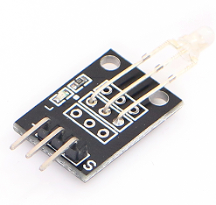

Color:Red and Green
5mm
Voltage (V)：2.0-2.5
Current (MA)：10
Angel：150
Wavelength(NM)：571+644
(MCD)：20-40；40-80

//Arduino test code:
int redpin = 11; // select the pin for the red LED
int bluepin =10; // select the pin for the blueLED
int val;

void setup() {
pinMode(redpin, OUTPUT);
pinMode(bluepin, OUTPUT);
Serial.begin(9600);
}

void loop()
{
for(val=255; val>0; val--)
{
analogWrite(11, val);
analogWrite(10, 255-val);
delay(15);
}
for(val=0; val<255; val++)
{
analogWrite(11, val);
analogWrite(10, 255-val);
delay(15);
}
Serial.println(val, DEC);
}

